0.12 C → Assembly → Hardware
Take a simple statement:
GPIOA->ODR |= (1 << 5);
You already know what this means conceptually:
Set bit 5 of the GPIOA output data register.
But the STM32 CPU doesn't understand C.
The Cortex-M3 executes machine instructions.
So there is a transformation pipeline.
1. C source
You write:
GPIOA->ODR |= (1 << 5);
This is human-friendly programming language.
↓
2. Compiler
The compiler translates the C program into assembly instructions appropriate for the target CPU.
Conceptually:
C statement
↓
ARM/Thumb assembly
The exact assembly depends on the compiler, optimization settings, and surrounding code, so we should not memorize a particular instruction sequence.
↓
3. Assembler
The assembler converts assembly instructions into machine-code representation that the processor can execute.
↓
4. Linker
Your project isn't usually just one source file.
You may have:
main.c
startup file
HAL files
other .c files
libraries
The linker combines the compiled pieces and determines where code and data belong in memory.
For example:
Flash
0x08000000
│
├── Vector table
├── Program code
└── Constants

SRAM
0x20000000
│
├── .data
├── .bss
├── heap
└── stack
↓
5. Executable image
The build system produces an executable image such as an ELF file.
It can also generate formats such as HEX for programming the MCU.
↓
6. Flash
The program is programmed into the STM32's internal Flash.
After reset, the Cortex-M3 starts executing instructions from the programmed image.
↓
7. CPU executes instructions
The Cortex-M3 fetches instructions from memory and executes them.
Eventually it reaches the instructions corresponding to:
GPIOA->ODR |= (1 << 5);
↓
8. Memory-mapped peripheral access
This is where our earlier memory-mapped I/O concept becomes extremely important.
GPIOA's ODR has a specific address.
The CPU performs a memory access to that address.
The bus/interconnect routes that access to the GPIO peripheral.
↓
9. GPIO hardware changes
The GPIO peripheral updates the corresponding output bit.
For PA5:
ODR bit 5 = 1
↓
GPIO output logic
↓
PA5 output becomes HIGH
Now software has caused a physical electrical change on the MCU pin.

The complete picture
YOU
│
▼
C CODE
│
▼
COMPILER
│
▼
ASSEMBLY CODE
│
▼
ASSEMBLER
│
▼
MACHINE CODE
│
▼
LINKER
│
▼
ELF / HEX
│
▼
STM32 FLASH
│
▼
CORTEX-M3
│
▼
BUS
│
▼
GPIO REGISTER
│
▼
GPIO HARDWARE
│
▼
PA5 PIN
│
▼
PHYSICAL SIGNAL
That's the software → silicon → electricity chain.

Three things I want you to remember
① C is not what the CPU executes
C → compiler → machine instructions → CPU
② Registers are the bridge
Your C code can control hardware because peripheral registers are memory-mapped.
C code
↓
register access
↓
bus
↓
peripheral hardware
③ The build process matters
When you eventually start writing bare-metal STM32 code, understanding this pipeline will help you understand:
- startup files
- linker scripts
- vector tables
- .text
- .data
- .bss
- Flash/SRAM placement
- compiler output
- debugging
You don't need to master those yet. We will encounter them naturally at the appropriate level.

Final Level 0 checkpoint
Answer these three:
Q1. The Cortex-M3 cannot directly execute C code. What does it actually execute?
Q2. Why can a C statement modify a hardware peripheral register?
Q3. Put these in the correct order:
Linker
C source
Machine code
Compiler
Flash
CPU
Once you answer these, we'll officially mark LEVEL 0 COMPLETE and move into Level 1, where things start getting much more hands-on. 🚀

Answers:
- C → compiler → machine instructions → CPU
- because they are memory mapped
- c source, compiler, machine code, linker, CPU, flash

Perfect. 3/3 correct. ✅
One small ordering correction for Q3:
You gave:
C source → Compiler → Machine code → Linker → CPU → Flash
The conceptual build/programming flow is better represented as:
C source
↓
Compiler
↓
Machine code / object code
↓
Linker
↓
Executable image
↓
Flash
↓
CPU
So you had the right components, but Flash comes before CPU execution.
Q1
Correct. The Cortex-M3 ultimately executes machine instructions.
Q2
Correct. Because peripheral registers are memory-mapped, normal load/store operations can access hardware registers.
Q3
Almost perfect. Just remember:
Link → program into Flash → CPU fetches and executes.

🎓 LEVEL 0 COMPLETE
You've now covered the complete foundation:
0.1 MCU Fundamentals ✅
0.2 ARM Ecosystem ✅
0.3 STM32 Ecosystem ✅
0.4 Cortex-M3 Architecture ✅
0.5 Memory ✅
0.6 Registers & Bit Manipulation ✅
0.7 Programmer's Model ✅
0.8 Buses ✅
0.9 Clock & Reset ✅
0.10 Interrupt Fundamentals ✅
0.11 Startup Sequence ✅
0.12 C → Assembly → Hardware ✅
Your Level 0 mental model should now be:
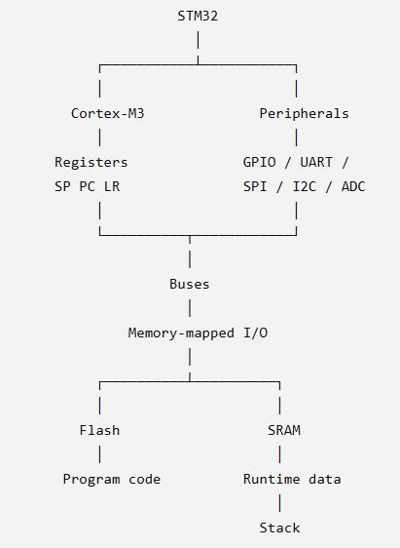

And the software side:
C
↓
Compiler
↓
Machine instructions
↓
Flash
↓
Cortex-M3
↓
Bus
↓
Peripheral register
↓
Hardware
This is the foundation we'll build everything else on.

